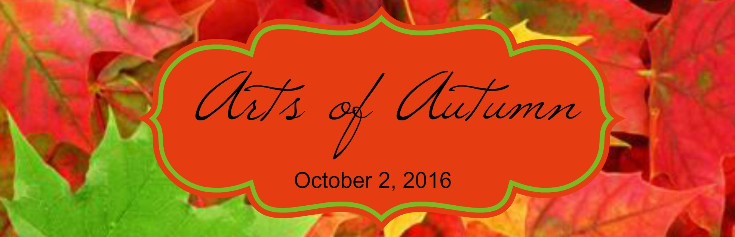

Conversations & Co.
Invites you to apply to participate in the 1st Annual Arts of Autumn Event. The vendors will be nestled in the lots surrounding the Victorian Home of Conversations & Co. located off Tallmadge Circle in the beautiful city of Tallmadge, Ohio on Sunday October 2, 2016 from 11:am – 5:pm. This event will highlight Artists and Crafters as well as a booth of authors and services focused on women’s health and well being. Arts of Autumn is free to the public with free parking.
To apply, please read these instructions thoroughly. Complete and return application form with payment. Applications will be accepted until the show is full or until September 16, 2016, whichever comes first.
General Information: More than 25 artists and crafters will display and sell their original works. Demonstrations are encouraged. No rain date. Art and craft vendors should have Ohio Transient Vendor License.
Eligibility: Original works of art only. ALL applicants must submit three (3) close-up photos of art at time of application or submit website where their work can be viewed. ABSOLUTELY NO manufactured, commercial, wholesale or offensive material will be permitted. If Artists/Vendors come with a majority of items not described on the application, we retain the right to request you to leave under misrepresentation.
Entry Fee: All Art/Vendor lots are 10ft x 10ft with an added 2ft space between exhibitors. All spaces are $40 excluding food vendors. Entry fee must be submitted with application. If application is denied for any reason, entry fee check will not be cashed and will be voided.
Site Description/Requirements: We encourage you to bring a 10x10 tent to protect you from the elements of the weather. All spaces are on blacktop. We advise you to bring weights for the corners of your tents. Electricity is not available. Artists/Vendors must provide all display furnishings including table and chairs. Every effort will be made to limit Artists/Crafters creating like arts/crafts. If there are any, they will be assigned spaces away from each other. Three food trucks will be available to purchase meals/snacks. Port-a-johns are on site. Picnic tables will be available throughout event site. Set up time will be October 2, 2016 from 8:30 am – 10:45 am. Event is open to the public from 11:am until 5:pm. ABSOLUTELY NO tear down prior to 5:pm. Parking is available in close proximity and is free. Artists/Vendors assume full responsibility for loss or damage to person or property. You will receive confirmation and space assignment by email on September 22, 2016.
Artists/Vendors must comply with all regulations or risk being asked not to return for the 2017 Arts of Autumn Event.
Email your questions to: jana.tucker704@gmail.com
Arts of Autumn Show Director – Jana Tucker (330) 714-1163

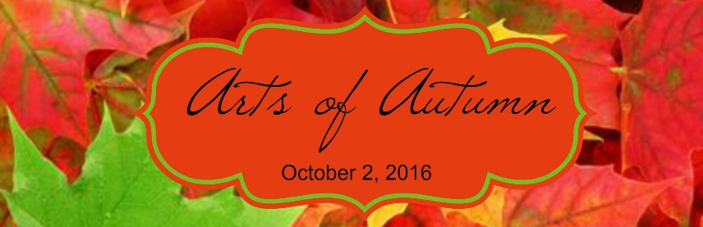
Hosted by Conversations & Co.

APPLICATION FORM
Please fill out completely and be specific ~ THANK YOU

NAME ___________________________________________________________________________________
ADDRESS, CITY, STATE, ZIP________________________________________________________________
PHONE_______________________________________SECOND PHONE_____________________________
EMAIL___________________________________________________________________________________
ITEMS TO BE SOLD _______________________________________________________________________
__________________________________________________________________________________________
__________________________________________________________________________________________
__________________________________________________________________________________________
WEBSITE/ONLINE STORE/ETSY/ETC.________________________________________________________
__________________________________________________________________________________________
I hereby state that all items are made by me/us and I/we agree to and will abide by the terms stated in this application.
SIGNATURE________________________________________________________DATE_________________
All applications must be submitted with application fee of $40. No refunds after September 16, 2016. Checks will be cashed only after review of application and acceptance of Artist / Crafter.

Please make check payable to:
Conversations & Co.

Mail this application form and check to:
Conversations & Co.
Attention: Jana
22 Northwest Ave.
Tallmadge, OH 4478

